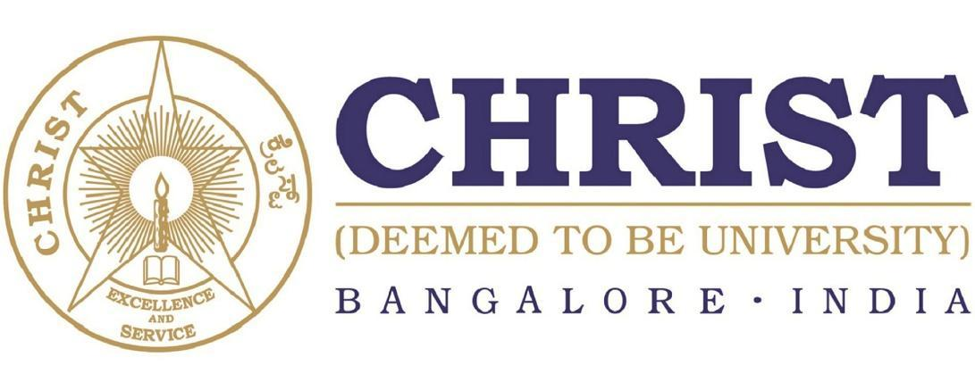

**DEPARTMENT OF**

**COMPUTER SCIENCE AND ENGINEERING**

**Programming Paradigm**

**CS433P**

***B. Tech – Computer Science and Engineering***

***(Artificial Intelligence and Machine Learning)***

**School of Engineering and Technology,**

**CHRIST (Deemed to be University),**

**Kumbalagodu, Bengaluru-560 074**

April 2023



***Certificate***

*This is to certify that Ashvath Suresh Babu Piriya, Yamini.K, D.Sai Pranathi has successfully completed the ~~record /~~ Mini Project work for (CS433P - Programming Paradigm) in partial fulfillment for the award of Bachelor of Technology in Computer Science and Engineering (Artificial Intelligence & Machine Learning) during the year 2022-2023.*

**HEAD OF THE DEPARTMENT FACULTY- IN CHARGE**

**EXAMINER 1:**

**EXAMINER 2:**

Name : Ashvath S.P, *Yamini.K, D.Sai Pranathi*

Register No. : 2162014, 2162054, 2162071

Examination Center : SoET, CHRIST (Deemed to be University)

Date of Examination :